PROJECT DEVELOPMENT PHASE

USER ACCEPTANCE TESTING (UAT) – RESULTS AND SIGN-OFF

Project Name: Metro Ticket Generating System in ServiceNow

1. UAT Execution Details

Parameter | Details
Project | Metro Ticket Generating System
Platform | ServiceNow
Environment | ServiceNow PDI
User Interface | Service Portal
Tester | Konathala venkata satyalakshmi

2. UAT Results

UAT ID | Scenario | Actual Result | Status
UAT01 | Access booking service | Book A Metro Ticket opened successfully | Pass
UAT02 | Select stations | Starting and destination stations selected | Pass
UAT03 | Select journey type | Single/Return option worked correctly | Pass
UAT04 | Enter passenger count | Passenger count accepted successfully | Pass
UAT05 | Select payment mode | Payment mode logic worked correctly | Pass
UAT06 | Fare calculation | Fare calculated automatically | Pass
UAT07 | QR generation | QR code displayed successfully | Pass
UAT08 | Submit booking | Request generated successfully | Pass
UAT09 | View request | Booking details displayed successfully | Pass

3. Acceptance Criteria
The system is considered acceptable when:
- User can access the ticket-booking catalog item.
- User can enter valid journey details.
- Fare is calculated automatically.
- Journey type affects the fare correctly.
- Required fields are validated.
- QR code is generated and displayed.
- Booking request is created successfully.
- Booking details are available after submission.

4. UAT Conclusion
The Metro Ticket Generating System was tested against the defined user acceptance scenarios. The ticket booking workflow, dynamic fare calculation, payment-mode behavior, QR code generation, and request submission were successfully validated during testing.
6. UAT Test Evidence
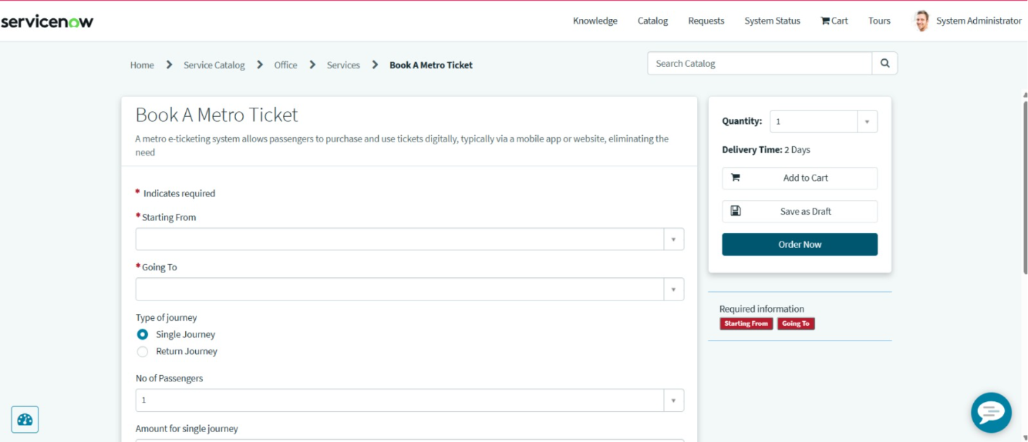
Figure 1: User entering metro journey and passenger details
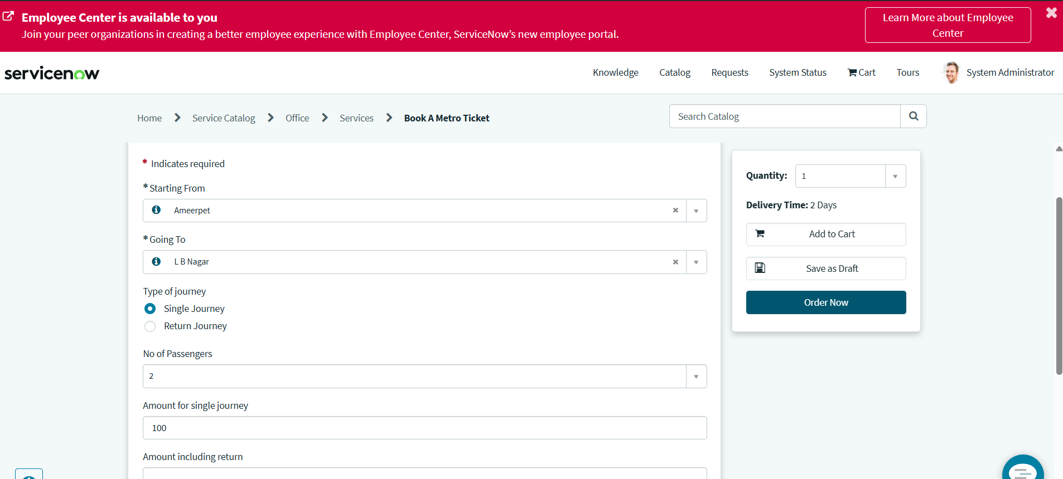
Figure 2: Fare automatically calculated based on user selections
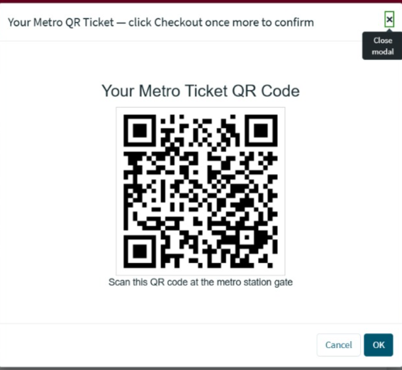

Figure 3: QR-based digital metro ticket displayed to the user

